Configure EtherChannel

# 

# Port Channel Table

|  |  |  |
| --- | --- | --- |
| Channel Group | Ports | Protocol |
| 1 | S1 F0/21. F0/22  S3 F0/21, F0/22 | PAgP |
| 2 | S1 G0/1, G0/2  S2 G0/1, G0/2 | LACP |
| 3 | S2 F0/23, F0/24  S3 F0/23, F0/24 | Negotiated LACP |

# Instructions

## Configure Basic Switch Settings

* + - 1. Assign each switch a hostname according to the topology diagram.
      2. Set all the ports being used as Trunks.
      3. Run the show spanning command on all 3 switches and fill in table:

Close configuration window

**S1 Bid: 32769 S2 Bid:32767 S3 Bid:32769**

|  |  |  |  |  |  |
| --- | --- | --- | --- | --- | --- |
| **G0/1** | **Desg** | **G0/1** | **Altn** | **F0/21** | **Desg** |
| **G0/2** | **Desg** | **G0/2** | **Altn** | **F0/22** | **Desg** |
| **F0/21** | **Root** | **F0/23** | **Root** | **F0/23** | **Desg** |
| **F0/22** | **Altn** | **F0/24** | **Altn** | **F0/24** | **Desg** |

## Which Switch is the Root Bridge: SWITCH

## Configure an EtherChannel with Cisco PAgPf

### Configure Port Channel 1.

Open configuration window

* + - 1. Use the **show interfaces trunk** command to ensure that you have an active trunk link for those two links, and the native VLAN on both links is the same.

S1# **show interfaces trunk**

Port Mode Encapsulation Status Native vlan

F0/21 on 802.1q trunking 1

F0/22 on 802.1q trunking 1

G0/1 on 802.1q trunking 1

G0/2 on 802.1q trunking 1

<output omitted>

* + - 1. The first EtherChannel (PaGP) that is created aggregates ports F0/21 and F0/22 between **S1** and **S3**.
      2. On S1 and S3, add ports F0/21 and F0/22 to Port Channel 1 with the **channel-group 1 mode desirable** command. The **mode desirable** option enables the switch to actively negotiate to form a PAgP link. **Note:** Interfaces must be **shutdown** before adding them to the channel group.

S1(config)# **interface range f0/21 – 22**

S1(config-if-range)# **shutdown**

S1(config-if-range)# **channel-group 1 mode desirable**

S1(config-if-range)# **no shutdown**

S3(config)# **interface range f0/21 - 22**

S3(config-if-range)# **shutdown**

S3(config-if-range)# **channel-group 1 mode desirable**

S3(config-if-range)# **no shutdown**

The message “Creating a port-channel interface Port-channel 1” should appear on both switches when the channel-group is configured. This interface designation will appear as Po1 in command output.

### Verify Port Channel 1 status.

* + - 1. Issue the **show etherchannel summary** command on S1 and S3 to verify that EtherChannel is working on both switches. This command displays the type of EtherChannel, the ports utilized, and the port states. Command output is shown for S1.

S1# **show etherchannel summary**

Flags: D - down P - in port-channel

I - stand-alone s - suspended

H - Hot-standby (LACP only)

R - Layer3 S - Layer2

U - in use f - failed to allocate aggregator

u - unsuitable for bundling

w - waiting to be aggregated

d - default port

Number of channel-groups in use: 1

Number of aggregators: 1

Group Port-channel Protocol Ports

------+-------------+-----------+----------------------------------------

1 Po1(SU) PAgP F0/21(P) F0/22(P)

Close configuration window

## Configure an 802.3ad LACP EtherChannel

### Configure Port Channel 2.

* + - 1. To configure port channel 2 as LACP, use the interface configuration mode **channel-group** *2* **mode active** command. Active mode indicates that the switch actively tries to negotiate that link as LACP, as opposed to PAgP. The configuration of S1 is shown below. Repeat for S2 also

Open configuration window

S1(config)# **interface range g0/1 - 2**

S1(config-if-range)# **shutdown**

S1(config-if-range)# **channel-group 2 mode active**

S1(config-if-range)# **no shutdown**

S1(config-if-range)# **interface port-channel 2**

S1(config-if)# **switchport mode trunk**

### Verify Port Channel 2 status.

Use the **show** commands from Part 1 Step 2 to verify the status of Port Channel 2. Look for the protocol used by each port.

## Configure a Redundant EtherChannel Link

### Configure Port Channel 3.

* + - 1. Configure Port channel 3 as LACP between S2 and S3

### Verify Port Channel 3 status.

* + - 1. Use the **show** commands from Part 1 Step 2 to verify the status of Port Channel 3. Look for the protocol used by each port.
      2. Creating EtherChannel links does not prevent Spanning Tree from detecting switching loops. View the spanning tree status of the active ports on **S1**.

S1# **show spanning-tree active**

VLAN0001

Spanning tree enabled protocol ieee

Root ID Priority 32769

Address 0001.436E.8494

Cost 9

Port 27(Port-channel1)

Hello Time 2 sec Max Age 20 sec Forward Delay 15 sec

Bridge ID Priority 32769 (priority 32768 sys-id-ext 1)

Address 000A.F313.2395

Hello Time 2 sec Max Age 20 sec Forward Delay 15 sec

Aging Time 20

Interface Role Sts Cost Prio.Nbr Type

---------------- ---- --- --------- -------- --------------------------------

Po1 Root FWD 9 128.27 Shr

Po2 Altn BLK 3 128.28 Shr

* + - 1. Run the show spanning command on all 3 switches and fill in table:

**S1 S2 S3**

|  |  |  |  |  |  |
| --- | --- | --- | --- | --- | --- |
| **Po1** | **Root** | **Po2** | **Altn** | **Po1** | **Desg** |
| **Po2** | **Desg** | **Po3** | **Root** | **Po3** | **Desg** |

Which Switch is the Root Bridge: switch 3

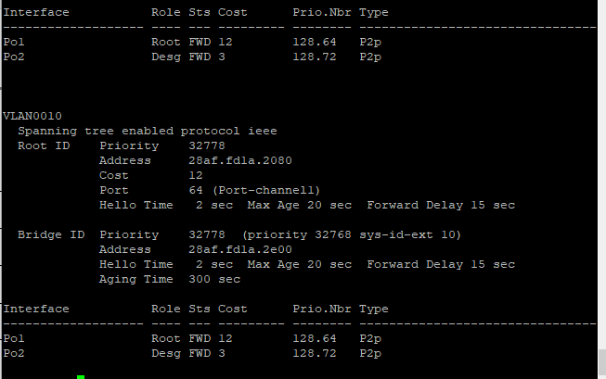

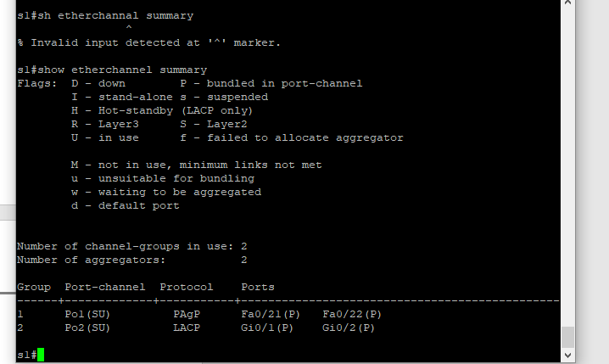

nd of document

**Part 5: Changing the Root Bridge**

Make S2 the Root bridge (Note if S2 is already the root bridge then make S1 the rootbridge

S2(config)# **spanning-tree vlan 1 root primary**

Close configuration window

What is the new Priority on S2: 24577

